

WinMan® Bridge – Magento Extension
User Guide

Version: 2.0.0
Prepared by: Lynn Eagleton

The contents of this document are confidential and should not be disclosed to any third party without the prior written consent of Systemware Services Limited

Contents

Overview 3
Prerequisites 4
System Prerequisites 4
Data Prerequisites 4
Tax Rules, Rates and Classes 4
Freight Methods 5
Payment Methods 6
Installation 7
Configuration 8
General 8
Enable Bridge? 8
API Base URL 8
Website URL 8
API Access Token 8
Enable Bridge Logging? 8
Products 9
Fetch Products from WinMan? 9
Fetch Product Stock Levels from WinMan? 9
Fetch Product Images from WinMan? 9
Fetch Product Categories from WinMan? 9
Perform Full Product Update? 9
Perform Full Product Category Update? 9
Customers 10
Fetch Customers from WinMan? 10
Send New Customers a Welcome Email? 10
Perform Full Customer Update? 10
Sales Orders 10
Push Sales Orders back to WinMan? 10
Cron Schedule 10
Data Population and Export 11
Custom Attributes 11
Product Attributes 11
Category Attributes 11
Customer Attributes 11
Products 11
Product Images 12
Product Stock Levels 12
Product Categories 13
Customers 13
Sales Orders 15
Request Account Page 16
Customer Portal 17
Account Overview 18
Sales Orders 18
Quotes 20
Invoices 21

Overview

The WinMan Bridge makes it possible for products, product categories and customers to be automatically populated in Magento 2.x from a WinMan application, and for orders created in Magento 2.x to be automatically sent back to a WinMan application via the WinMan REST API.

Once installed and configured, the majority of the functionality of the WinMan Bridge runs via your Magento cron schedule.

This document covers version 2.0.0 of the WinMan Bridge.

Prerequisites

System Prerequisites
- WinMan v7.0098.31.
- WinMan REST API v2.0.0.
- Magento v2.2.1 or higher. The extension might work with versions of Magento 2.x which are older than v2.2.1, but this has not currently been tested and is not supported.
- Your Magento cron must be set up and working.

Data Prerequisites

Tax Rules, Rates and Classes
Tax Rules, Rates and Classes are not created automatically by the WinMan Bridge, and must be created manually in Magento. Your Magento Tax Rules, Rates and Classes should be named in a way which matches up to the Tax Codes and Rates in your WinMan application. The WinMan Bridge will then automatically assign the correct Magento Tax Class to the products that are populated.

For example, in WinMan, if you have a Tax Code of STD which has a Tax Rate of 20% and is applicable in the UK, you should follow the steps below to create the necessary information in Magento:

- Create a matching Tax Rate. In your Admin Panel, go to Stores -> Tax Zones and Rates -> Add New Tax Rate, and enter the information as shown below. Remember to click Save Rate when done.
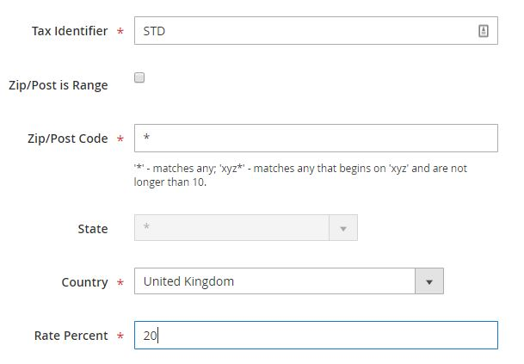

- Create a matching Tax Rule and product Tax Class. In your Admin Panel, go to Stores -> Tax Rules -> Add New Tax Rule. The Name of your new Tax Rule should be STD, and you should select STD from the Tax Rate box by clicking on it in the list box. Under Additional Settings, you should create a new Tax Class for products by clicking on the appropriate Add New Tax Class button. Please then ensure that your new product Tax Class is selected by clicking on it in the list box. Please also select all the customer Tax Classes by clicking on them. Once you have entered the necessary information, the first part of the page should look something like the below. Remember to click Save Rule when done.

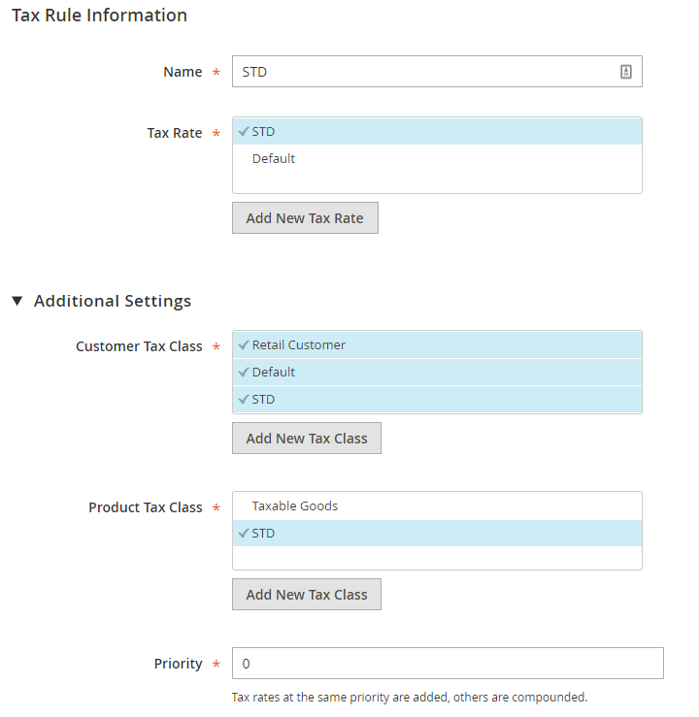

You may wish to experiment with different Tax Rules depending on your needs. The most important part for the WinMan Bridge is that a product Tax Class exists in Magento for each Tax Code in WinMan. The names must match exactly, as these are what the WinMan Bridge looks for when syncing data. If the WinMan Bridge is unable to find a matching product Tax Class in Magento, the product will have no tax class assigned to it, essentially making it tax exempt.

Freight Methods
In order for Magento orders to be successfully sent back to WinMan, your Magento shipping methods must have a Method Name which matches up exactly to an appropriate FreightMethodId in WinMan.

Payment Methods
In order for Magento orders to be successfully sent back to WinMan, your Magento payment methods must have a Title which matches up exactly to an appropriate CreditCardTypeId in WinMan.

Installation

The WinMan Bridge cannot currently be installed via Composer and must be installed manually. Please note that this process will take your Magento site offline until the installation is complete. To install, follow these steps:

- The extension will be provided in the form of a ZIP file. Extract the app directory from the ZIP file into your Magento root directory.
- On your server, cd to your Magento root directory and run the following commands:

php bin/magento setup:upgrade
php bin/magento setup:di:compile
php bin/magento setup:static-content:deploy

- If you have cache enabled, you should flush your cache either via the Admin Panel (System -> Cache Management -> Flush Magento Cache) or by issuing the following command:

php bin/magento cache:flush

- Once the above steps are completed, you should check that the extension is listed and enabled in your Admin Panel under Stores -> Configuration -> Advanced -> Advanced.

Configuration

Once you have successfully installed the WinMan Bridge, you can configure it in your Admin Panel under Stores -> Configuration -> WinMan -> WinMan Bridge. If your Magento site has multiple websites, you should configure the WinMan Bridge at website level by selecting the appropriate website from the Store View drop-down. If you have only one website, the WinMan Bridge can safely be configured at the Default Config level.

General

Enable Bridge?
You should set this option to Yes to enable the WinMan Bridge. If it is set to No, no information will be passed between WinMan and Magento.

API Base URL
You should set this option to reflect the base URL of your WinMan REST API. When your WinMan REST API was set up by WinMan, both a Training and a Live base URL will have been created. For more information on this, please see the WinMan REST API documentation.

Website URL
You should set this option to reflect the URL of your Magento website, exactly as it appears in the WinMan application under the Ecommerce Websites program. For more information on this, please see the WinMan REST API documentation.

API Access Token
You should enter a valid WinMan REST API Access Token in this box. For more information on this, please see the WinMan REST API documentation.

Enable Bridge Logging?
The WinMan Bridge is capable of producing log output for information and debugging purposes. You should set this option to No if you would like to disable this output. If this option is set to Yes, the log output will be saved in the winman_bridge.log file located in Magento’s var/log directory. For production environments, it is recommended that this option is set to No.

Products

Fetch Products from WinMan?
If you would like to populate products in Magento from WinMan, you should set this option to Yes.

Fetch Product Stock Levels from WinMan?
If you would like to keep the stock levels of your products in Magento in sync with the stock levels in WinMan, you should set this option to Yes. If Fetch Products from WinMan? is set to No, this option will be ignored.

Fetch Product Images from WinMan?
If you would like to fetch your product images directly from WinMan, you should set this option to Yes. Please note that if you do set this option to Yes, any additional images you add to WinMan products manually through the Admin Panel will be removed from these products the next time the WinMan Bridge updates them. If Fetch Products from WinMan? is set to No, this option will be ignored.

Fetch Product Categories from WinMan?
If you would like to populate product categories in Magento from WinMan, you should set this option to Yes. This option will not only create and update the product categories themselves, but it will also place any relevant WinMan products into these categories. If Fetch Products from WinMan? is set to No and this option is set to Yes, product categories will be created but may not have products added into them.

Perform Full Product Update?
By default, the WinMan Bridge will only fetch product data from WinMan that has changed since the last time the data was fetched. If you would like to force the WinMan Bridge to fetch all relevant product data from WinMan, regardless of when it was last modified, you should set this option to Yes. If this option is set to Yes, the full update will occur the next time the cron job runs. Once the full update is completed, this setting will automatically revert to No.
If Fetch Product Images from WinMan? is set to Yes, product images will also be included in this full update. If Fetch Products from WinMan? is set to No, a full product update will not occur.

Perform Full Product Category Update?
By default, the WinMan Bridge will only fetch product category data from WinMan that has changed since the last time the data was fetched. If you would like to force the WinMan Bridge to fetch all relevant product category data from WinMan, regardless of when it was last modified, you should set this option to Yes. If this option is set to Yes, the full update will occur the next time the cron job runs. Once the full update is completed, this setting will automatically revert to No.

Customers

Fetch Customers from WinMan?
If you would like to populate Magento customers from WinMan, you should set this option to Yes. The data that is populated in Magento comes from a combination of data from WinMan CRM Contacts and WinMan Customers. For more information on this, please see the WinMan REST API documentation.

Send New Customers a Welcome Email?
If you would like Magento to send a welcome email to customers who are newly created by the WinMan Bridge, you should set this option to Yes. If this option is set to No, the WinMan Bridge can still create new customers but these customers will not be notified.

Perform Full Customer Update?
By default, the WinMan Bridge will only fetch customer data from WinMan that has changed since the last time the data was fetched. If you would like to force the WinMan Bridge to fetch all relevant customer data from WinMan, regardless of when it was last modified, you should set this option to Yes. If this option is set to Yes, the full update will occur the next time the cron job runs. Once the full update is completed, this setting will automatically revert to No.

Sales Orders

Push Sales Orders back to WinMan?
If you would like orders placed within Magento to be automatically sent back to the WinMan application, you should set this option to Yes. If this option is set to Yes, orders are sent back to WinMan as soon as they are placed in Magento – you do not have to wait for the cron job to run.

Cron Schedule
The WinMan Bridge has its own cron group. To manage the settings for this cron group, go to Stores -> Configuration -> Advanced -> System -> Cron (Scheduled Tasks) -> Cron configuration options for group: winman in your Admin Panel.
By default, the WinMan Bridge cron job is set to run every 15 minutes.

Data Population and Export

Custom Attributes
Upon installation, the WinMan Bridge creates several custom attributes which may be populated with data from WinMan. These are as follows:

Product Attributes
Unit of Measure | This is set to the UnitOfMeasurePrintText from WinMan.
Barcode | This is set to the Barcode from WinMan.
Pack Size | This is set to the PackSize from WinMan.
Length | This is set to the Length from WinMan.
Width | This is set to the Width from WinMan.
Height | This is set to the Height from WinMan.

Category Attributes
Category GUID | This is set to the ProductCategoryGUID from WinMan.

Customer Attributes
GUID | This is set to the CustomerGUID of the Customer in WinMan.
Communication Allowed | This is set to the AllowCommunication field of the CRM Contact in WinMan.

All the above product attributes are added to the Default Attribute Set, grouped together in a group called WinMan Attributes.

Products
When products are created by the WinMan Bridge, they are added to the website for which the extension is configured and use the Default Attribute Set. At present, only Simple products are created, but products which have Options and Options Items in WinMan will have the corresponding customisable options created in Magento automatically.
In addition to the custom attributes mentioned previously, the following standard Magento product attributes are populated by the WinMan Bridge:

Enable Product | This is set to Yes.
Product Name | This is set to the ProductDescription from WinMan.
SKU | This is set to the ProductId from WinMan.
Price | This is set to the WebPrice from WinMan, unless this is 0. If it is 0, this attribute is set to the StandardPrice from WinMan.
Tax Class | This is set to the tax class which has the same name as the TaxCodeId from WinMan. If no tax class exists in Magento with this name, this attribute is set to None. If Taxable is set to False in WinMan, the tax class is set to None.
Weight | This is set to the Weight from WinMan.
Visibility | This is set to Catalog, Search.
Description | This is set to the LongDescription from WinMan.
Short Description | This is set to the ShortDescription from WinMan.
Meta Title | This is set to the TitleTag from WinMan.
Meta Keywords | This is set to the KeywordsTag from WinMan.
Meta Description | This is set to the DescriptionTag from WinMan.
Customisable Options | If the product in WinMan has Options and Options Items, the corresponding customisable options will be created automatically, including prices.
Please note that when products are removed from the Ecommerce Website in WinMan, they are not automatically removed from Magento.

Product Images
When product images are populated by the WinMan Bridge, any images that are currently added to the product in Magento are removed and replaced by the images fetched from WinMan. The first image fetched from WinMan is set as the base, small and thumbnail for the product.

Product Stock Levels
When product stock levels are populated by the WinMan Bridge, the following standard Magento product attributes are populated:
Manage Stock | This is set to Yes.
Qty | This is set to the sum of the quantity in stock across all inventory sites attached to the relevant website in WinMan.
Qty Uses Decimals | This is set to Yes.
Stock Status | If Qty is 0, this is set to Out of Stock. If Qty is greater than 0, this is set to In Stock.

Product Categories
When product categories are populated by the WinMan Bridge, they are created under the root category of the website for which the extension is configured, and their hierarchy matches that in WinMan.
In addition to the custom attributes mentioned previously, the following standard Magento category attributes are populated by the WinMan Bridge:
Enable Category | This is set to Yes.
Category Name | This is set to the ProductCategoryDescription from WinMan.
Category Image | This is set to the CategoryImage from WinMan, with base, small and thumbnail also set.
Description | This is set to the DescriptionTag from WinMan.
URL Key | This is set to a URL encoded version of the ProductCategoryDescription from WinMan.
Meta Title | This is set to the TitleTag from WinMan.
Meta Keywords | This is set to the KeywordsTag from WinMan.
Meta Description | This is set to the DescriptionTag from WinMan.
After the above attributes are populated, the appropriate products are added into the categories.
Please note that when categories are removed from WinMan, they are not automatically removed from Magento. Please also note that when products are removed from categories in WinMan, they are not automatically removed from those categories in Magento.

Customers
When customers are created by the WinMan Bridge, they are associated to the website for which the extension is configured.
In addition to the custom attributes mentioned previously, the following standard Magento customer attributes are populated by the WinMan Bridge:
Group | This is set to the customer group which has the same name as the customer’s PriceListId from WinMan. If no customer group exists in Magento with this name, the WinMan Bridge will create the group first and then set this attribute.
Disable Automatic Group Change Based on VAT ID | This is set to Yes (ticked).
Prefix | This is set to the Title of the CRM Contact in WinMan.
First Name | This is set to the FirstName of the CRM Contact in WinMan.
Last Name | This is set to the LastName of the CRM Contact in WinMan.
Email | This is set to the PortalUserName of the CRM Contact in WinMan.
Tax/VAT Number | This is set to the TaxNumber of the Customer in WinMan.

At present, a single address is created for the customer with the following attributes populated:

Prefix | This is set to the Title of the CRM Contact in WinMan.
First Name | This is set to the FirstName of the CRM Contact in WinMan.
Last Name | This is set to the LastName of the CRM Contact in WinMan.
Street Address | This is set to the Address of the Customer in WinMan.
City | This is set to the City of the Customer in WinMan.
Country | This is set to the ISO3Chars country code of the Customer in WinMan.
State/Province | This is set to the Region of the Customer in WinMan.
Zip/Postal Code | This is set to the PostalCode of the Customer in WinMan.
Phone Number | This is set to the PhoneNumberWork of the CRM Contact in WinMan.
Default Billing Address | This is set to Yes (ticked).
Default Shipping Address | This is set to Yes (ticked).

Newly created customers have their password randomly generated by Magento, and if the configuration option Send New Customers a Welcome Email? is set to Yes, they are sent a welcome email with a link to access their account. Customers which are being updated do not have their passwords changed.
Please note that CRM contacts which are removed from WinMan are not automatically removed from Magento.

Sales Orders
For orders which are sent back to WinMan by the WinMan Bridge, the following fields from the Magento order are sent to the appropriate EcommerceWebsite in WinMan:
Customer GUID
Grand Total | This is the total amount charged to the customer for the order in the customer’s currency.
Tax Amount
Order ID | This is used as the CustomerOrderNumber in WinMan.
Coupon/Promotional Code
Order Currency Code
Customer Email
SKU (of each product purchased) | If the product has customisable options, these options and their prices will also be included.
Quantity (of each product purchased)
Row Total | This the total price for the order row in the customer’s currency.
Tax Amount (for each order row) | This is the total amount of tax for the order row in the customer’s currency.
Shipping Method Name | This is used as the FreightMethodId in WinMan.
Shipping Amount | This is the total for shipping in the customer’s currency.
Shipping Tax Amount | This is the total amount of tax for shipping in the customer’s currency.
Shipping Address First Name + Shipping Address Last Name | This is used as the DeliveryName in WinMan.
Shipping Address Street Address | This is used as the DeliveryAddress in WinMan.
Shipping Address Zip/Postal Code | This is used as the delivery address PostalCode in WinMan.
Shipping Address Country Code | This is used as the ISO3Chars country code of the delivery address in WinMan.
Billing Address First Name + Billing Address Last Name | This is used as the CompanyName in WinMan when creating a new Customer.
Billing Address Street Address | This is used as the Customer’s Address in WinMan when creating a new Customer.
Billing Address Zip/Postal Code | This is used as the Customer’s PostalCode in WinMan when creating a new Customer.
Billing Address Country Code | This is used as the ISO3Chars country code of the Customer in WinMan when creating a new Customer.
Payment Method Title | This is used as the CreditCardTypeId in WinMan.
Total Paid | This is the total amount that the customer has paid online in the customer’s currency.

If the order is successfully sent to WinMan, its status in Magento is set to Complete and a note is added containing the WinMan Order ID. If the order is not successfully sent to WinMan, its status in Magento is set to On Hold and a note is added advising an Administrator to check the logs for more information. Please note that the customer is not notified of any change of order status which is made by the WinMan Bridge.
If the Magento customer does not have a Customer GUID (either because the account has been created in Magento, not via the WinMan Bridge, or because they are a guest), the WinMan Bridge will attempt to match up the customer’s email address to a CRM Contact’s PortalUserName in WinMan (provided the appropriate Program Profile has been enabled in WinMan. Please see the WinMan REST API documentation for more information on this). If a match is found, the order will be placed in WinMan using this existing CRM Contact and associated Customer. If no match is found, a brand-new CRM Contact, CRM Company and Customer will be created in WinMan (if possible). In all cases, the WinMan Bridge sends the Customer GUID from WinMan back to Magento after the order has been successfully placed in WinMan.

Request Account Page
The WinMan Bridge makes it possible for CRM Contacts to be created automatically in WinMan. A frontend page is created when the WinMan Bridge is installed which can be reached at
http(s)://<your_website_URL>/requestaccount. It contains a simple form for the potential customer to complete. Once all the mandatory fields are completed and the potential customer clicks the submit button, the data is automatically sent back to WinMan and CRM Contact and CRM Company is created. Within the WinMan application, this CRM Company can then be promoted to a full Customer, at which point, the WinMan Bridge will be able to automatically pick up the data again and create a Magento customer.
A success or failure message is displayed above the form to inform the potential customer whether their request was successfully sent to WinMan.

Customer Portal

The WinMan Bridge includes several Customer Portal pages which enable customers to view sales order, invoice, quote, statement and account overview information from WinMan within Magento. To access these pages, customers need to log in to their Magento account as normal and they will see additional links in the navigation menu, as highlighted below:
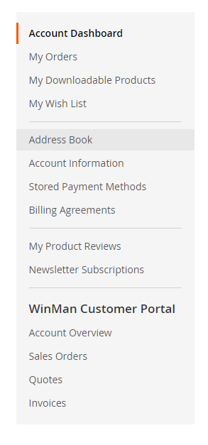
If the customer does not have a Customer GUID saved against their Magento customer account, they will not see these additional links.

Account Overview
From the account overview page, customers can view basic information about their WinMan account, download a PDF copy of their current WinMan statement, and view brief lists of the 5 most recent sales orders and sales invoices linked to their WinMan account. Customers can also click through to each of these recent sales orders and/or sales invoices to see further detail, click through to see a full list of all sales orders and/or sales invoices, and download PDF copies of theses recent sales orders and/or sales invoices. A typical account overview page looks like the below:
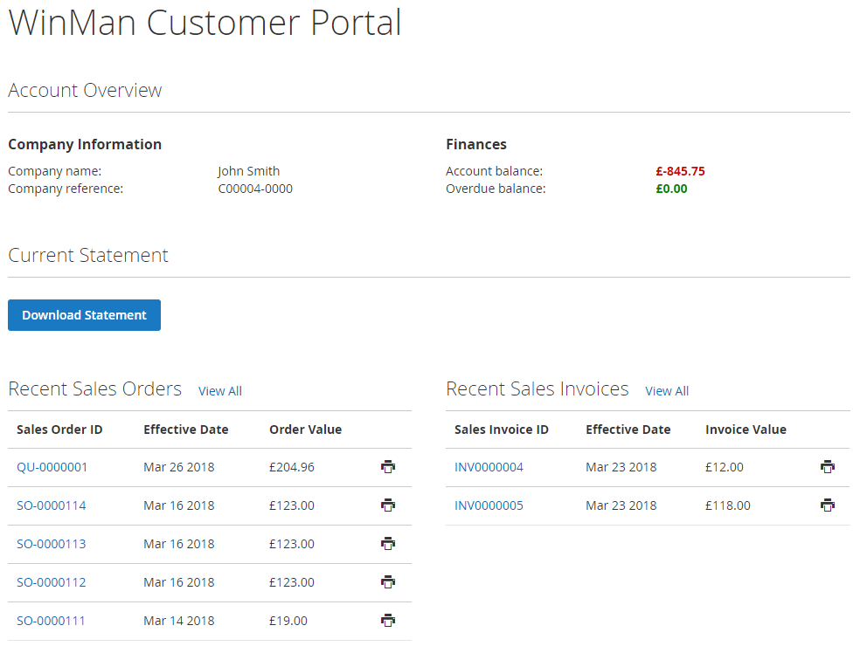

Sales Orders
From the sales orders page, customers can view a complete list of sales orders linked to their WinMan account. The list is paged, showing 10 items per page by default with the option to change this to 20 or 50. Customers can click through to individual sales orders to view further details, and download PDF copies of each sales order. A typical sales orders page will look like the below:
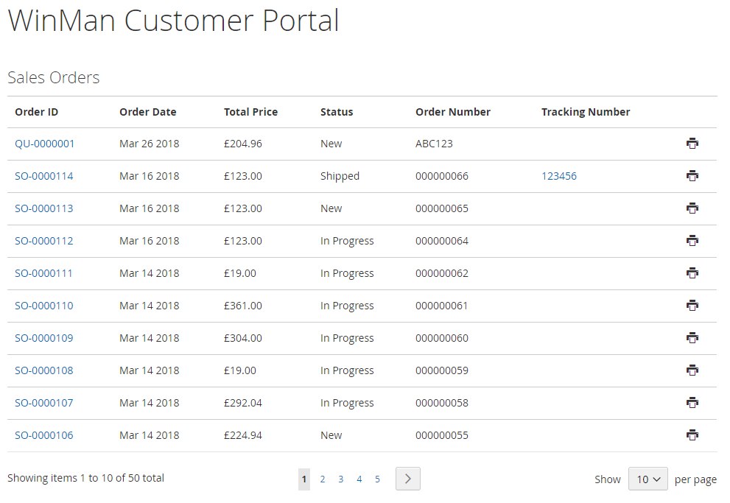
When a customer clicks through to an individual sales order, they will see additional details, including a complete list of all items on the order. A typical individual sales order page will look like the below:
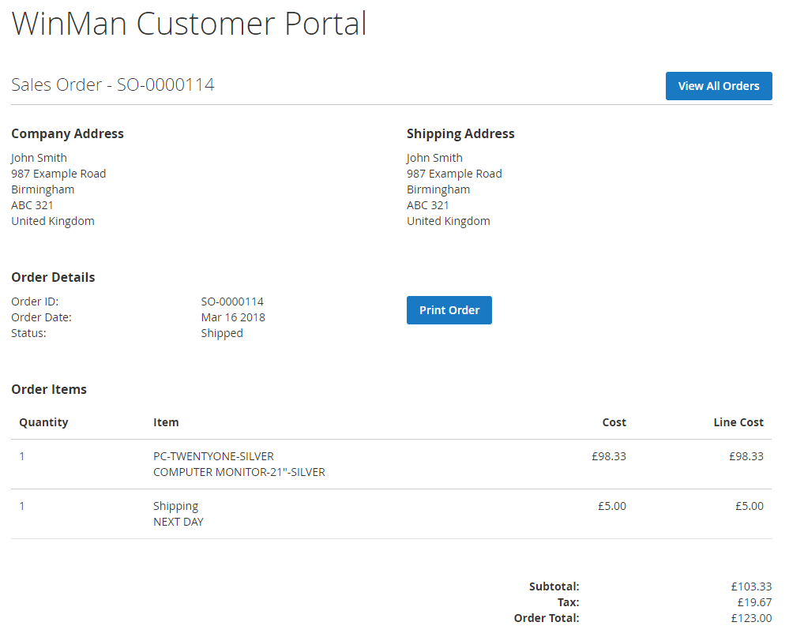

Quotes
From the quotes page, customers can view a complete list of quotes linked to their WinMan account. The list is paged, showing 10 items per page by default with the option to change this to 20 or 50. Customers can click through to individual quotes to view further details, and download PDF copies of each quote. A typical quotes page will look like the below:
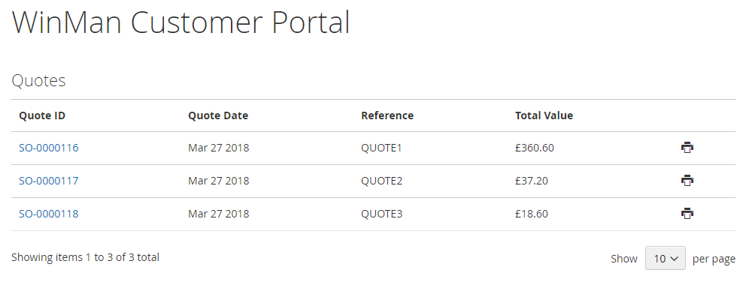

When a customer clicks through to an individual quote, they will see additional details, including a complete list of all items on the quote. There is also a button which allows the customer to convert the quote to a sales order. A typical individual quote page will look like the below:
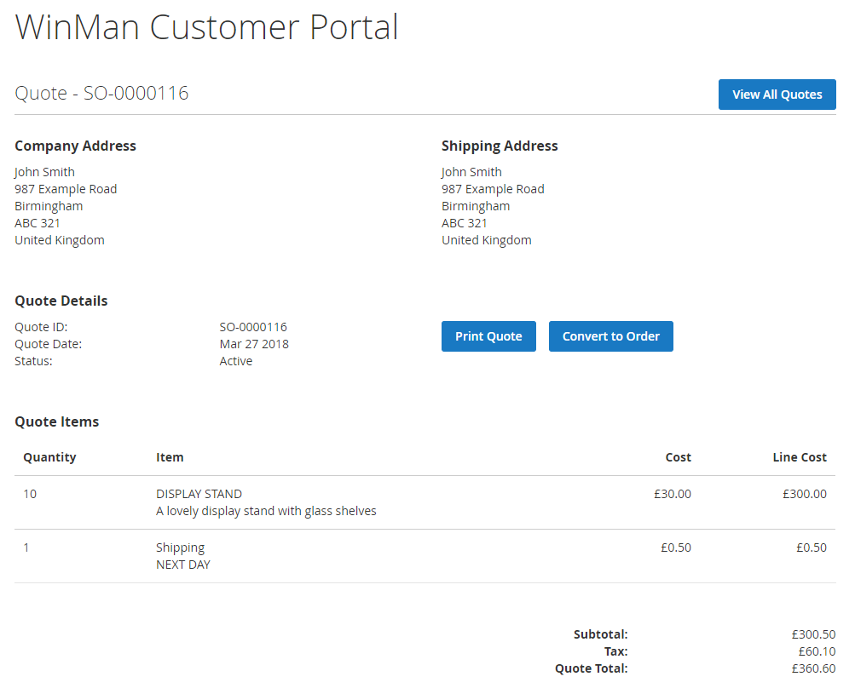

Invoices
From the invoices page, customers can view a complete list of invoices, credits and payments linked to their WinMan account. The list is paged, showing 10 items per page by default with the option to change this to 20 or 50. Customers can click through to individual invoices to view further details, and download PDF copies of each invoice. A typical invoices page will look like the below:
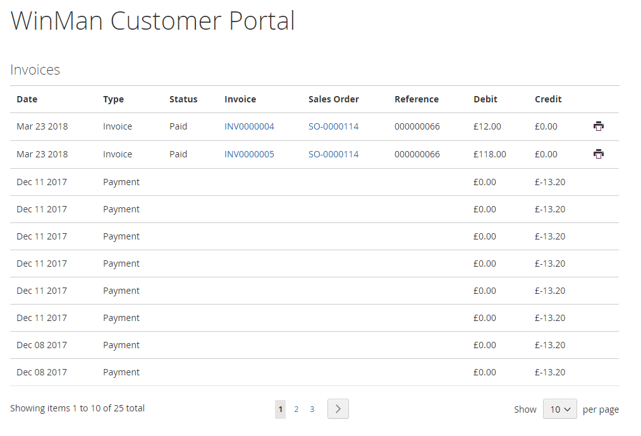

When a customer clicks through to an individual invoice, they will see additional details, including a complete list of all items on the invoice. A typical individual invoice page will look like the below:
